# LEARN TO RIDE

High-quality **Western and English** riding lessons, focusing on safety and including instruction on horse care, saddling a horse and other aspects of horsemanship.

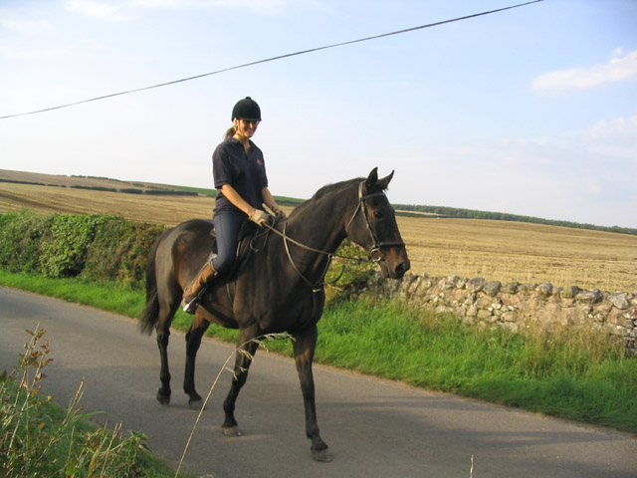

[This Photo](https://www.geograph.org.uk/photo/239729) by Unknown Author is licensed under [CC BY-SA](https://creativecommons.org/licenses/by-sa/3.0/)

* Novice to advanced instruction for children and adults.
* Indoor and outdoor arenas.
* $40 per hour for private lessons, $25 for group lessons.

*CALL TRI-VALLEY STABLES AT 555-2030 TODAY!*

